Pavers will be laid as part of the landscaping of the current
$10 million building program in 2024.
ENGRAVING DETAILS – MAX 17 CHARACTERS PER LINE
Please print clearly using ALL CAPITAL LETTERS. Max 3 lines per paver.
Each box represents a character (letter, number, punctuation mark or space). No hand drawings.
L 1
L 2
L 3

CONTACT DETAILS AND PAYMENT OPTIONS :
Name |  | Phone |  | Amount
 |  |  |  | $
Payment Options:
Cheques made to : St Arnaud Secondary College
Cash – Named Envelope to the General Office
Eftpos – Payment at General Office
Bpay – Family Account details

Cash – Named Envelope to the General Office

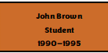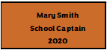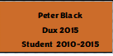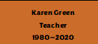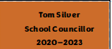

Personalised Engraved Paver - $25.00

